**Project Design Phase-I**

**Solution Architecture**

|  |  |
| --- | --- |
| Date | 14 October 2022 |
| Team ID | PNT2022TMID19942 |
| Project Name | University Admit Eligibility Predictor |
| Maximum Marks | 4 Marks |

**Solution Architecture:**

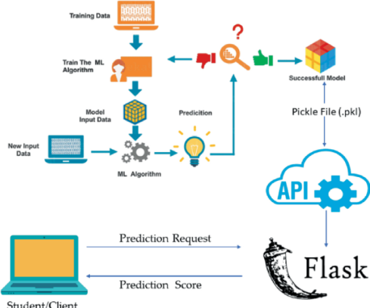

Figure 1: Architecture and data flow of the University Admit Eligibility Predictor